This is a sample header of this sample abstract
for Optics in Engineering OIE19
Mallu M. Mainio¹, Wille Wirtanen² and Taisto Tutkija¹
¹ Optics Laboratory, Virtual University of City, The City
² Photonics Department, University, The City
Corresponding author: mallu.mainio@unicity.wld
(Optional small paragraph describing the additional information concerning the authors may be added here, extending to several lines if needed)
Keywords: optics, lithography, nanostructures
This paragraph starts the text section of the abstract. The text is based on the Times New Roman font type using size 11 pt. The authors are kindly asked not to change the style definitions in the template. This helps the organizers to assemble the proceedings by using these similarly typesetted pages.
The first chapter should shortly view the background and introduce [2,4] the possibly unfamiliar reader to the main subject of the research.
This second/third/fourth chapter should stand as the main chapter(s) to clarify the aspects and ideas of the subject to be presented in oral speech/poster. The illustrative small table(s) and/or figure(s)/plot(s) are encouraged. The use of black/white or clear grayscale/raster techniques in formatting the figures is preferred.
Third start here… almost forgot! Would you add one to four keywords of the subject before the text section. These will be used for index purposes. One possibility to find the proper keywords is to use the Optics Classification and Indexing Scheme (OCIS), that can be found in http://www.osa.org/pubs/authors/ocis/.
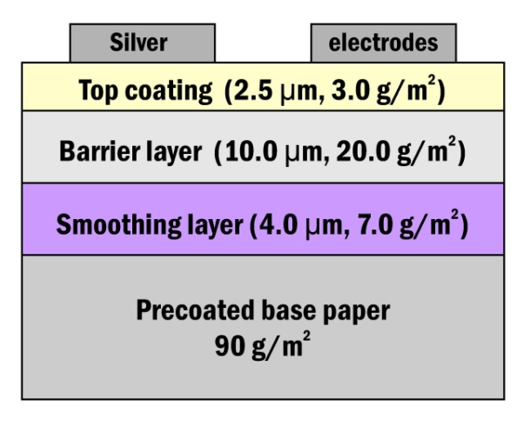

Fourth paragraphs starts here with some words about the figures: Simple Picture- of Metafile-formats can be used for embedded figure objects. Bitmaps can be used, too, but if possible, file size should be limited to less than 1Mb. EPS-files are naturally employed with LaTex-formatting. The minipage environment can be used to create small figures with the text along the figure. Please leave a minimum space of 5 mm between the text and the figure. Please refer figures in the text with abbreviation, for example, Fig. 1.

Fig. 1. A schematic picture
Alternative possibility is to use a full width centered images as follows:
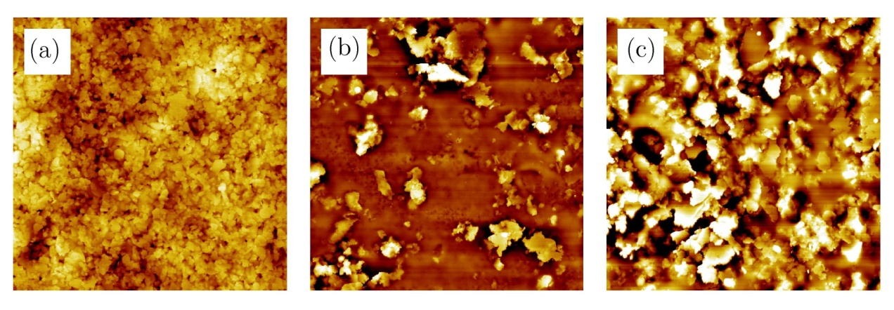
Fig. 2. Enter here.
Equations are also easily displayed such as
$f\left(x\right)=a_{0}+\sum_{n=1}^{∞}{\left(a_{n}\cos{\frac{nπx}{L}}+b_{n}\sin{\frac{nπx}{L}}\right)}$ (1)
To summarize, the preferred way to construct the abstract is to
1. Please be sure to use the provided template in MS Word or TeX,
2. Replace the text and other items with the real text/data,
3. Save it As file type Word format and convert it as a pdf-file (DO NOT secure the pdf-file),
4. Name it after the first author e.g. mainio.pdf
5. Email (possibly zipped) it as an Attachment file to the organizer with supplementary notes
The last chapter is a nice place to shortly make the conclusions and plans for future.
References

1. M. Mainio, J. Juonio, and T. T. Tutkija, Optics Journal 12, 123-129 (1998).
2. O.P. Guru and E. Stein, The major source book of the subject, (Publisher, Location, 1996).
3. More information can be found in: www.opticslab.unicity/research/thesubject.html, valid 2/2002
4. Tutorial information can also be found in: www.optics.uniworld/generalissues.html, valid 1/2002
5. Additional information

